Healthy athlete tip: Learn and use an ACL prevention exercise program
February 21, 2014
Anterior cruciate ligament tears are devastating knee injuries for athletes. We probably can never eliminate all ACL injuries in sports. If we can take steps to prevent some of them, though, I think we should try.
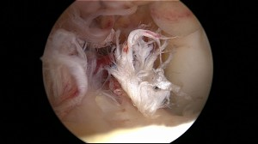Most ACL injuries result from noncontact mechanisms. An athlete might awkwardly land from a jump with her knee extended, and her knee buckles. Or she might plant her foot to change directions when her ACL ruptures.
ACL injury prevention programs aim to resolve the underlying factors contributing to these noncontact injuries. Usually they consist of 10to 15 minutes of simple exercises that replace traditional warm-up exercises. They develop neuromuscular balance and coordination throughout the lower extremity and teach proper landing and turning mechanics.

An athlete plays soccer wearing an ACL brace after surgery.
Generally sports medicine programs, physical therapists and athletic trainers teach these programs to sports teams. They can instruct the athletes and demonstrate the proper ways to do each movement. They can watch and correct players’ bad form. Then the players perform the exercises daily before and during the season.
Generally studies show that these programs decrease ACL injury rates. Some show significantly fewer ACL tears among players who do them compared to players who do not. Other studies show trends toward lower injuries but not as large of an effect.
Other than the 15 minutes or less each day spent doing these exercises, I don’t see a real downside to these programs. These exercises will still help you warm up before practices and games, and they might keep you out of the operating room.

